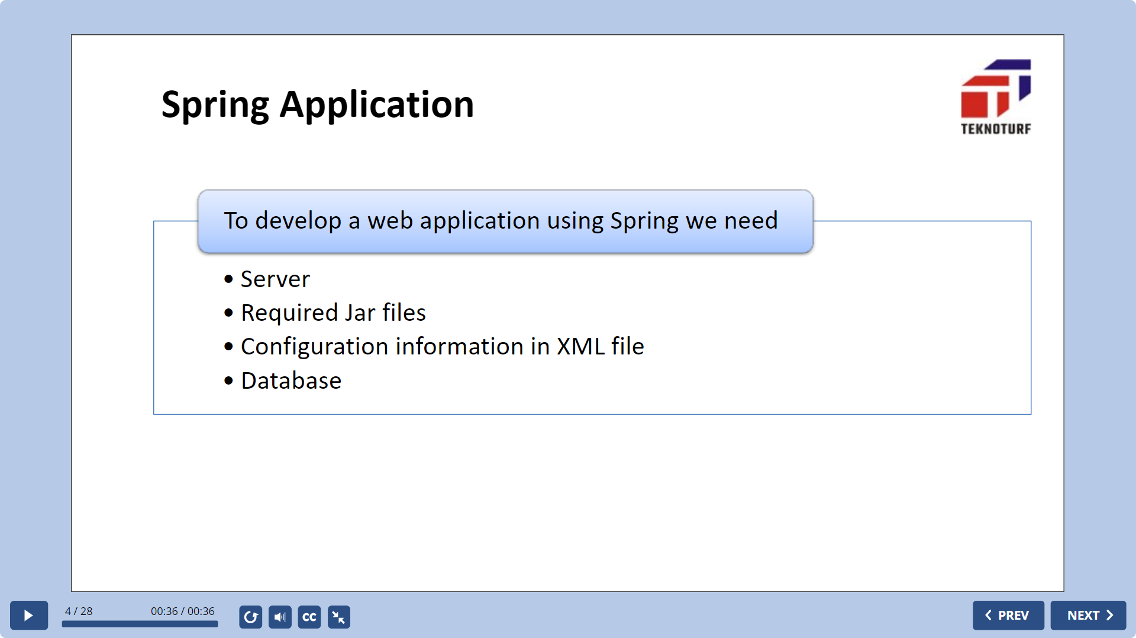

Spring boot has embedded server like Tomcat and Jetty

It uses build tools like Gradle or Maven

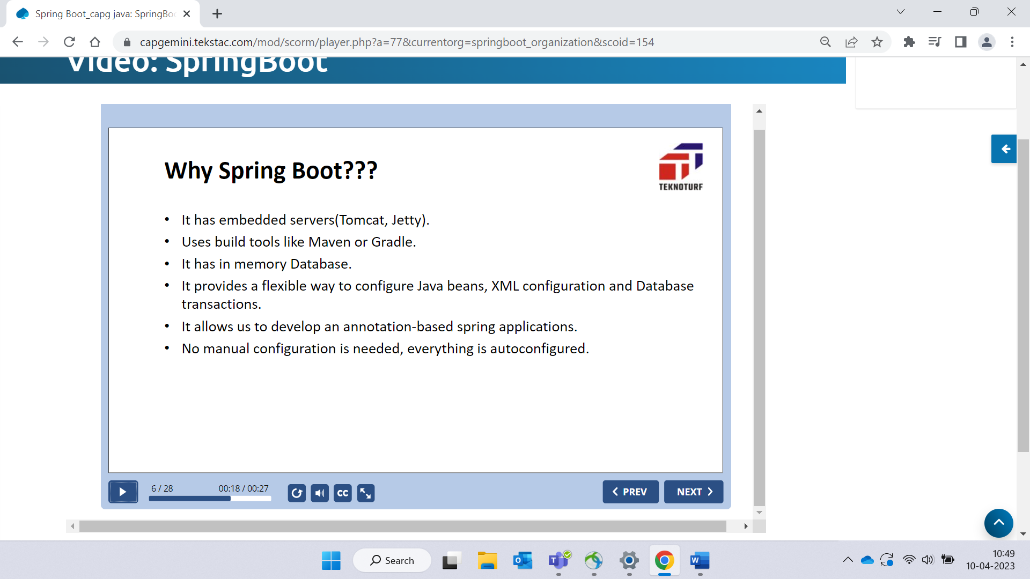

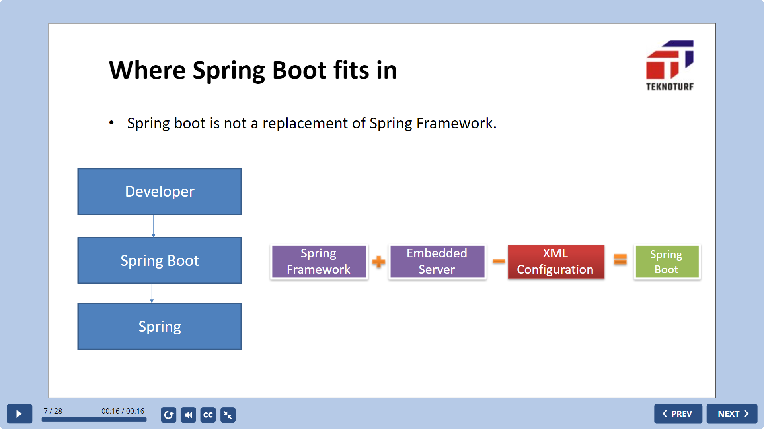

Spring boot components

1. Spring boot starter 🡪 combine related group of dependencies into single dependency
2. Spring boot autoconfiguration 🡪 reduces the spring configuration
3. Spring boot CLI 🡪 Used to run and test the application
4. Spring boot Actuator 🡪 It uses HTTP endpoints or JMX beans to enable us to interact with it.

Starter dependencies 🡪

Spring-boot-starter-data-jpa

Spring-boot-starter-data-test

Spring-boot-starter-data-jdbc

Spring-boot-starter-web

Spring-boot-starter-data-actuator

